**Module 5**

**Name: Upadhyay Sachin Naresh**

**Batch ID: AIWDE0B 300821**

**Topic: Deep Learning Primer**

1.What activation function should I use in the case of ?

1. Classifiers Ans: Sigmoid/tanh
2. Vanishing gradient problem Ans: ReLU
3. Generalised Ans: Linear
4. Only in hidden layers Ans: ReLU
5. Only in Output layer Ans: Linear, sigmoid, softmax

2. Calculate the error of a following perceptron

Whose values are given as below

|  |  |  |  |
| --- | --- | --- | --- |
| Sno | Inputs(x) | Weights | Output |
| 1 | 0.5 | 0.6 | 1.62 |
| 2 | 0.006 | 0.001 |  |
| 3 | 0.1 | 0.005 |  |
| 4 | 0.4 | 0.67 |  |
| 5 | 0.8 | 0.45 |  |

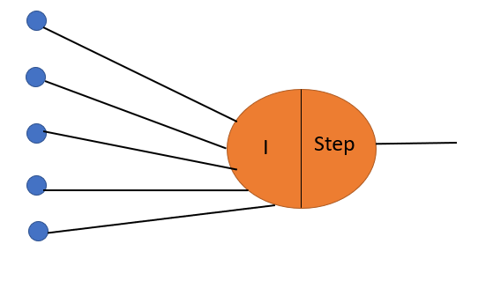

**Answer:**

Output for the given perceptron as per the given weights is = 0.5*0.6 + 0.006*0.001 +

0.1*0.005 + 0.4*0.67 + 0.8*0.45 = 0.928.

Since the output value is greater than zero the so the output from the activation function is 1.

So, the error is = 1.62-1 = 0.62.

3. Write down the steps involved in Back Propagation and the disadvantages of using Back Propagation.

**Answer:**

Steps involved in Back Propagation:

1. The weights are randomly initialised for each and every neuron

2. Calculate the summation or integration function for each neuron

3. Take the function of integration that is nothing but with the help of required activation function

4. Finally calculate the loss function

5. Calculate derivative of old weights with the help of chain rule

6. Now update old weight by subtracting old weight with the derivatives

7.Finally will get new updated weight

Disadvantages of using Back Propagation:

1.The actual performance of backpropagation on a specific problem is dependent on the input data.

2.Back propagation algorithm in data mining can be quite sensitive to noisy data.

3. You need to use the matrix-based approach for backpropagation instead of mini-batch.